ARTICLE CHECKLIST AND AUTHOR DECLARATION FORM

Please Complete and sign this form. Check each item to ensure that your article complies with the format and ethical requirements of The Indonesian Journal of Gastroenterology, Hepatology and Digestive Endoscopy (INA JGHE).

Type of Article (please specify):
☐ Editorial X Original Article ☐ Case Report ☐ Review Article

Title Page:
X Title of the article
X Full name(s) of author(s) and institutional affiliation(s)
X Correspondence address of the principal (corresponding) author

Abstracts and Keywords:
X Abstracts are written in both English and Indonesian consists of 100–250 words
X Keywords consist of 3–10 words

Main Text (depending on the type of article)
Original Article:
X Introduction
X Methods
X Results
X Discussion
X Conclusion
X Conflict of Interest
X Funding / Financial Support Statement
X Acknowledgment
X Author Contribution
☐ Data Availability
X References

Case Report:
☐ Introduction
☐ Case Illustration
☐ Discussion
☐ Conclusion
☐ Conflict of Interest
☐ Funding / Financial Support Statement
☐ Acknowledgment
☐ Author Contribution
☐ Data Availability
☐ References

For Review Article:
☐ Introduction
☐ Review of the Literature / Main Themes
☐ Conclusion
☐ Conflict of Interest
☐ Funding / Financial Support Statement
☐ Acknowledgment
☐ Author Contribution
☐ Data Availability (if applicable)
☐ References

Figures and Tables:
X Figures and/or tables are numbered in Arabic numerals
X Captions for all tables and legends for all figures are included

References:
X References follow Vancouver style
X All cited references are listed and verified

Submission Format:
X The electronic version of the manuscript has been uploaded through the online submission system (OJS).

Contact Information
Name: Lutfie
Address: Department of Internal Medicine, Primaya Evasari Hospital, Jakarta, Indonesia
Phone (home): -
Cellular phone: (+62) 85213508203
E-mail: lutfie040991@yahoo.com

AUTHOR DECLARATION AND ETHICAL STATEMENTS:
Title of Article: The Role of Mastery Learning in Advancing Skills in Abdominal Ultrasound: Insights from a Comprehensive Training Workshop for Internists
The author(s) guarantee(s) that:
a. All authors have participated sufficiently in this work to take public responsibility for its content.
b. All authors have reviewed and approved the final version of the manuscript for publication.
c. Neither this manuscript nor one with substantially similar content under my (our) authorship has been published or is being considered for publication elsewhere.
d. This manuscript has been submitted with the full knowledge and approval of the institution or department given as the affiliation of the author(s).
e. Manuscripts submitted to the Indonesian Journal of Gastroenterology, Hepatology and Digestive Endoscopy (INA JGHE) will not be withdrawn before an editorial decision (acceptance or rejection) has been made.

f. Conflict of Interest:
X All authors declare no conflicts of interest.
☐ Conflicts exist (please specify): _____________________________________
g. Funding / Financial Support:
☐ No funding was received for this work.
X Funding source(s): This study was supported by Philips and GE, for providing ultrasound machine used in this workshop.
h. Ethical Approval:
This study was approved by the Ethics Committee of the Fatmawati General Hospital (Approval Number: DP.04.03/DXXI.2/7818.2025, dated July 14, 2025).
☐ Not applicable

i. Copyright Transfer:
X Authors retain the copyright of this article and grant The Indonesian Journal of Gastroenterology, Hepatology and Digestive Endoscopy (INA JGHE) the right of first publication. The work is simultaneously licensed under a Creative Commons Attribution License (CC BY), which allows others to share and adapt the work with proper acknowledgment of its authorship and initial publication in this journal.

j. Author Contributions:
Example: A.B. designed the study; C.D. collected data; E.F. analyzed data; G.H. drafted the manuscript.

k. Author Declaration and Consent Form:
We, the undersigned authors, confirm that we have reviewed and approved the final version of this manuscript, agree with its submission to The Indonesian Journal of Gastroenterology, Hepatology and Digestive Endoscopy (INA JGHE), and consent to its publication if accepted.

Signature of the principal author,
Date: December 16th, 2025

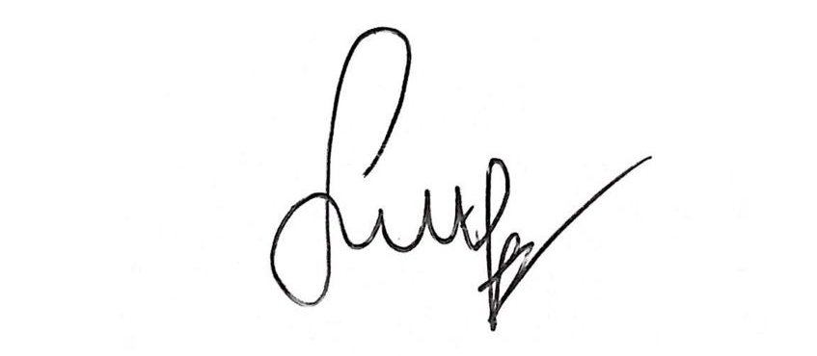
( Lutfie )

Signature of the co-author(s):

Full Name Date of Approval Signature

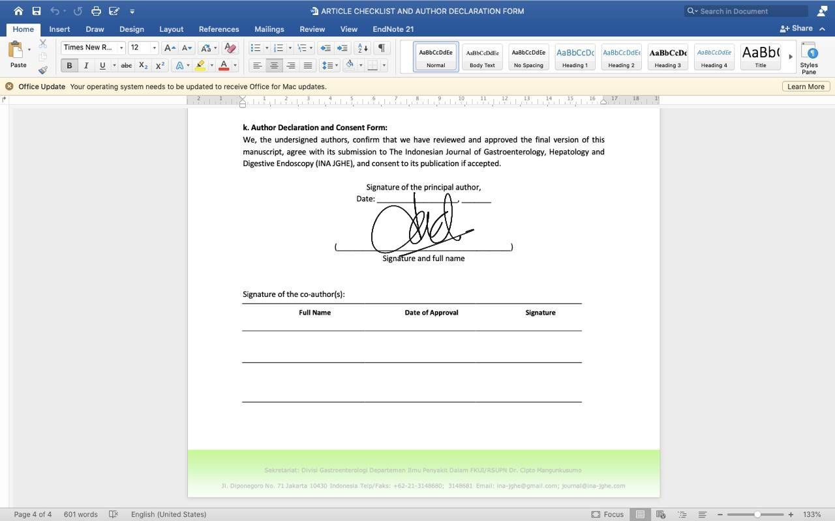
Nikko Darnindro Nov 24, 2025

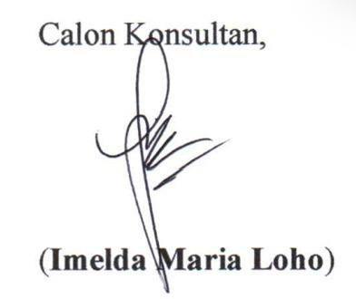
Imelda Maria Loho Dec 11, 2025


Steven David Panggabean Nov 24, 2025
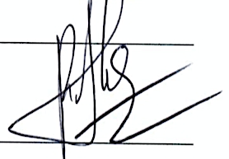

Ryan Herardi Nov 30, 2025

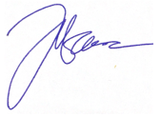

Pitt Akbar Nov 24, 2025


Bhanu Kumar Nov 29, 2025

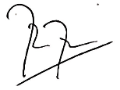
Rabbinu Rangga Pribadi Nov 24, 2025

