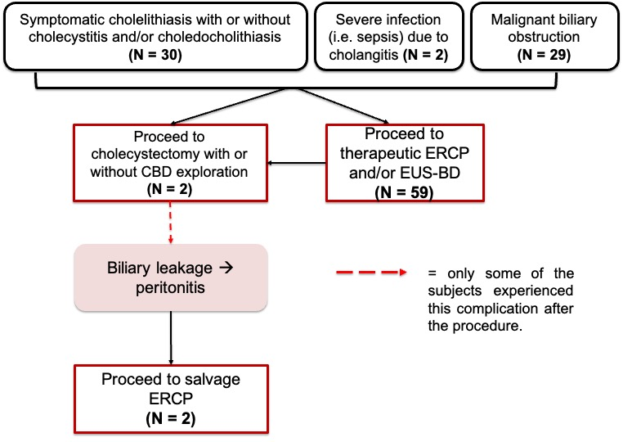
Figure 1. Flow chart of the study subjects’ management.

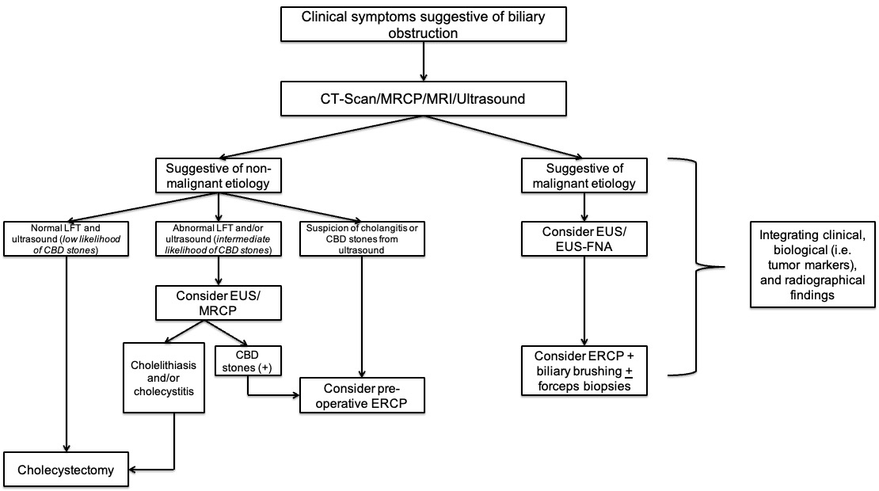

Figure 2. Proposed algorithm for management of complicated biliary cases.

FIGURE LEGENDS

Figure 1. Flow chart of the study subjects’ management. This flow chart summarizes the sequential events of the subjects in this study, since the admission until the therapeutic procedures.

Figure 2. Proposed algorithm for management of complicated biliary cases.

